**US 003-TC 003_002:** **8** **Verify the presence of fileds in filter.**

Step 1: Navigate to swag labs site

Step 2: Login as "standard_user" into the website

Step 3: Click on the filter in the home page

Step 4: Check if only below fields are present in the filter  
1. Price (low to high)  
2. Price (high to low)

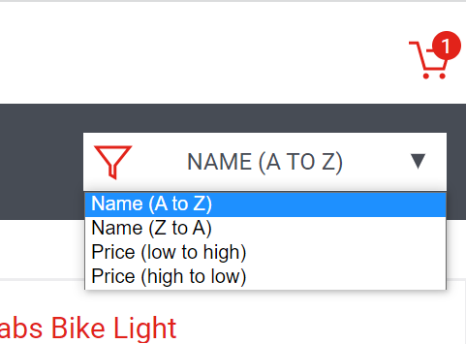

**User is able to see extra filter options in homepage filter.**

**Test case Failed.**

**Bug Raised.**